A Predictive Path Dependent Model for Global Fishing Patterns
Path Dependence in Global Fishing Patterns

Edward Tekwa, Eli P. Fenichel, Simon Levin, Malin Pinsky

July 14, 2017

[Nature Letters guideline for first paragraph: One or two sentences providing a basic introduction to the field, comprehensible to a scientist in any discipline. Two to three sentences of more detailed background, comprehensible to scientists in related disciplines. One sentence clearly stating the general problem being addressed by this particular study. One sentence summarizing the main result (with the words “here we show” or their equivalent). Two or three sentences explaining what the main result reveals in direct comparison to what was thought to be the case previously, or how the main result adds to previous knowledge. One or two sentences to put the results into a more general context. Two or three sentences to provide a broader perspective, readily comprehensible to a scientist in any discipline, may be included in the first paragraph if the editor considers that the accessibility of the paper is significantly enhanced by their inclusion. Under these circumstances, the length of the paragraph can be up to 300 words.]

The sustainable harvest of natural resources is becoming increasingly imperative to support growing populations and demands, yet mismanagement persists worldwide¹. Variations in harvest sustainability may be explained by institutional differences, such as governance strength and conservation agendas, but even apparently ideal and identical institutions can greatly diverge following slight historical differences. This hypothesis belongs to the cross-disciplinary concept of path dependence, which is often theoretically and descriptively explored in socio-ecological systems^{2–4}, evolutionary histories^{5,6}, cell developments^{7–9}, ecological systems^{10–15}, and economic developments^{16–18}. However, no predictive model of path dependence has been tested across systems outside of experiments, perhaps because natural systems are presumed too different from each other. Marine fishery management is a promising test case for path dependence because there are rich global datasets with standardized ecological¹⁹ and economic²⁰ metrics; but given the complexity of humans and nature, it would be surprising if a mechanistic model would be predictive here. Nevertheless, starting from the premises of gradual institutional change and exclusive resource access, our one-parameter model predicts that when the fish is ecologically desirable but relatively costly, fisheries optimally harvest at a low rate if they start below a threshold, but overharvest if they start above the threshold. The predicted non-linear path dependence of harvest rates on fish growth and cost/benefit ratio explains a large and significant portion of the variations among 217 fisheries world-wide (R²=0.311, p=3.0e-5). The result moves path dependence from a descriptive concept to a predictive framework, and shows that complex phenomena can arise from relatively simple agents². Path dependence implies that undesirable policies can be hard to shake, but also leaves hope for nearly-irreversible shifts toward desirable policies and resource sustainability.

Surveying marine fishery harvest patterns and the related literature suggests that path dependence may partly explain the variation in fishery harvest rates, or the portion of the current stock that is harvested per year²¹. In an era where resource sustainability is increasingly recognized²² and mandated²³, harvest rates remain highly heterogeneous, with 31.4% of global fisheries still overharvesting²⁴. Path dependent harvest rate is different from the issue of multiple stability in fish stock^{25–27} due to complex (non-unimodal) growth dynamics²⁸ or a constant harvest policy²⁹. The possibility of high harvest rate policies where a lower optimum exists is often explained using institutional differences, such as the lack of management leading to open access³⁰, or the devaluation of the future manifesting in high discounting³¹. However, another line of reasoning seeks to explain overharvesting without directly invoking discounting and cooperation, and indeed alludes to path dependence. This is articulated as a shifting baseline³², where fishery managements set targets and limits based on the prevailing harvests, or as a ratchet effect²³, where institutions are politically pressured against decreasing established harvest rates even when it is otherwise socioeconomically desirable. In formal economic theory, rational managers are expected to arrive at a single optimal harvest rate³³, but limited management control can lead to multiple attractors^{3,4}. In the following single-stock model, management limitation comes through attraction to local peaks in rent (benefit minus cost) as a function of harvest rate, rather than through convergence to a globally optimal strategy.

In our model, we assume that each fishery has exclusive access to a fish stock, that stocks quickly equilibrate in response to harvest, and that fisheries change their harvest rates slowly by small increments. With no discounting, these appear to be ideal conditions for managers to implement socially optimal policies. The fishery includes fishers and governing bodies of the stock, thus rents are defined as landing value minus variable operating cost and government subsidy²⁰. The stock grows logistically, while the benefit from harvest exhibits diminishing return. This scenario exhibits the hallmarks of complex adaptive systems²: individual fisheries adapt locally, with a time-scale separation between resource and strategy dynamics, resulting in global patterns that are not necessarily optimal or unimodal. The model solutions (see Methods) are expressed in Equation 1 as $\hat{F^{*}}$=log₂(F*/F_{MSY}), or the log ratio of harvest rates F* over the harvest rate of maximum sustainable yield (F_{MSY}), the rate that results in the highest possible sustained harvest. This normalized form makes different fisheries comparable; conveniently, it takes the value of 0 when the fishery harvests at F_{MSY}, is negative when harvesting below F_{MSY}, and is positive when harvesting above F_{MSY} ($\hat{F^{*}}$=1 if the stock is deterministically harvested to extinction in finite time). The solutions are determined by three factors: 1.) ln(MSY[kg]), 2.) γ , the cost/benefit ratio (operating cost+subsidy)/landing value), and 3.) a scaling factor ξ that approximates the number of fisheries in each geopolitical region (see Methods).

Equation 1

$$\hat{F^{*}}=0,\log_{2}\left(1±\sqrt{1-\frac{ξ}{\ln\left(MSY[kg]\right)γ}}\right)$$

The harvest rate solutions and their stabilities are illustrated in Figure 1a with respect to γ. At low MSY and γ, F_{MSY} is the single attractor. At high MSY and γ (γln(MSY)=ξ), the solutions are path dependent, with basins of attraction at F^{*+} and F^{*-} now divided by the repeller F_{MSY}. These solutions form a pitchfork bifurcation with a critical point ξ, and can be understood using an economic phase diagram (Figure 1b). From a rent perspective, the optimal economic yield (OEY) is determined by cost and benefit (γ). When cost is relatively low, a fishery would like to harvest a lot but is limited by resource recruitment, or how fast the stock can grow (MSY, or the height of the growth curve in Figure 1b). Thus, at low γ, the fishery is ecologically constrained and operates at F_{MSY}. As the relative cost goes up, the fishery becomes economically constrained, with the OEY moving down past MSY along the resource recruitment y-axis, intercepting the hump-shaped stock growth curve at two points that correspond to S^{F*+}, or higher than MSY stock (S_{MSY}) and S^{F*-}, or lower than MSY stock. These can be achieved using two linear consumption paths, defined by the harvest rates F^{*+} and F^{*-} respectively. Both strategies are ecologically and strategically attracting in the long run, and can be obtained using traditional economic techniques³⁴ (see Supplementary Material). This is in fact a less sophisticated approach than modern economic optimization³⁵, which generally produces a single, non-linear, and time-dependent consumption path that maximizes the present value of harvest at all time points. The non-linear consumption path leads to a socially optimal harvest rate of F^{*-}, or the lower equilibrium in our model³⁶. The difference in our approach is the assumption that fisheries do not optimize through time, but rather gradually change their strategies based on long-run rents. The model can be generalized using more complex resource growth functions, diminishing return functions, and additional bias to strategy change, with no qualitative change in harvest rate predictions (see Supplementary Material).

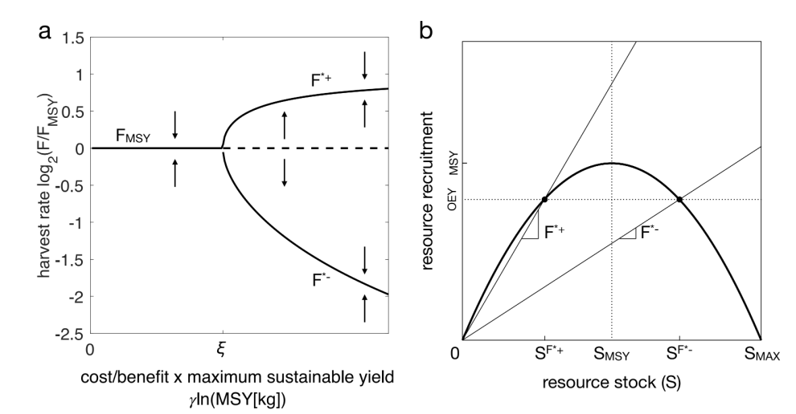
Figure 1. a. Model predictions on harvest rate attractors (solid curves) and repeller (dotted line) as a function of cost/benefit γ times ln(MSY). A pitchfork bifurcation occurs with a critical point at ξ. b. Economic phase diagram of resource recruitment (or harvest) versus stock. The thick solid curve represents the natural growth or recruitment curve of the stock as a function of stock. The recruitment is the MSY at S_{MSY}, and is 0 at either 0 or stock carrying capacity (S_{MAX}). The economically optimal equilibrium, accounting for cost, is to maintain the stock that yields the optimal economic yield (OEY) (horizontal dotted line). This can be achieved by adopting a constant harvest rate, or harvest per stock unit (slopes of linear paths), that is either high (F^{*+}) or low (F^{*-}). These rates result in either a low (S^{F*+}) or high (S^{F*-}) stable stock.

Our model generates an unintuitive hypothesis: the ecologically most desirable (high MSY) and economically least desirable (high γ) fisheries, which are economically rather than ecologically constrained, should be path-dependent. To test this hypothesis, we use the RAM Legacy database, which contains data on 217 global fisheries with MSY and F_{MSY} estimates in multiple years between 1961-2009¹⁹. These can be considered closely managed fisheries by virtue of their data availability, and thus satisfy our model’s assumption of resource excludability. We combine these fisheries data with additional country-level data on economic costs (variable cost + subsidy) and benefits (landing value) for 1990-2000²⁰ (see Methods). We use the state of the first reported harvest rate of each fishery (the binary of whether F_{init}>F_{MSY}) as the initial condition that determines the expected path. 52 fisheries initially harvested above F_{MSY}, while 165 began below F_{MSY}. We wish to explain the distribution in the temporal means of the harvest rates log₂(F/F_{MSY}), excluding the first reported year. The mean of log₂(F/F_{MSY}) is -0.511 (std=1.54). The data distributions are summarized in Figure 2, and can be accessed in the Supplementary dataset.

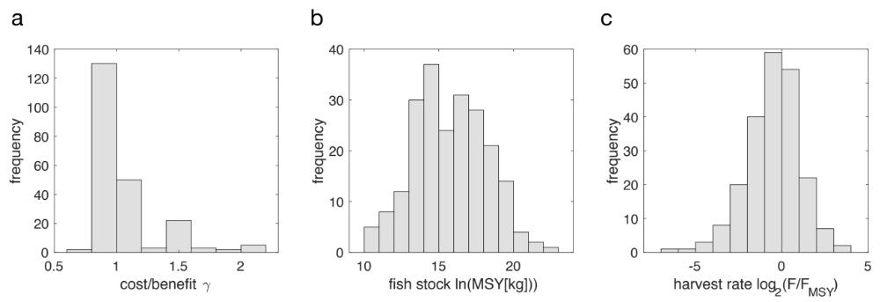
Figure 2. Distributions of a. cost/benefit ratio γ, b.stock maximum sustainable yields (MSY), and c. relative harvest rates log₂(F/F_{MSY}) in the RAM Legacy database.

The predicted attractors of the model (Equation 1), with a single parameter ξ, are fitted to harvest rates using γ, MSY, and initial conditions as inputs. The model is severely constrained in term of how it can fit the data, as ξ can only move the bifurcation point along the single dimension of γln(MSY) (Figure 1a). With ξ=11.1, the model explains (as R²) 0.311 of the variations in harvest rates across the globe. Figure 3a shows the apparent data trends that fisheries initially harvesting below F_{MSY} (open circles and blue shades) generally converge to the decreasing harvest rate attractor (F^{*-}) with increasing γln(MSY), while fisheries initially harvesting above F_{MSY} (filled circles and red shades) generally converge to the increasing harvest rate attractor (F^{*+}) with increasing γln(MSY). At low γln(MSY), fisheries A permutation test^{37–39} (see Methods) shows that the model explained the observations significantly better than when fitted against randomized mean harvest rates (p=3.0e-5, Figure 3b). In other words, if the harvest rate data were to have no relationship with γ, MSY, and initial conditions as the model hypothesized, the fit would be much worse. The mean of the model R² fitted to permuted data is R²_{rand}=0.138 (std=0.0442, p=7.30e-4), which can be understood as the portion of variations in the pure distribution of harvest rates (Figure 2c) explained by the model’s bimodality predictions. This still leaves a large portion of variations (ΔR²=0.173, std=0.0442, p=3.0e-5) explained by the model’s hypothesis that fisheries should increasingly diverge from F_{MSY} at higher γ and ln(MSY). Further, to test whether one economic optimum solution alone³⁶ could explain the harvest rate variations when compared to the path-dependent model solutions, we fitted a version of our model that retains only the lower harvest rate solution regardless of initial conditions. This model variant and the converse variant (with only the upper solution retained) both explain less variation than the mean (R²=-0.111), indicating that the path-dependent solutions are warranted.
Figure 3. a. Fitted model predictions on attracting (solid curves) and repelling (dotted line) harvest rates as a function of γln(MSY), or cost/benefit times log of maximum sustainable yield, with the RAM Legacy fishery data plotted as either filled or open dots depending on initial conditions. The blue or red shades indicate the empirical harvest rate probability densities (along the y-axis) of fisheries starting below or above the rate of maximum sustainable yield. b. R² of the model fitted to the actual data (vertical line) compared to the null R² distribution obtained from fitting the model to permuted harvest rates (repeated 100000 times). c, d. Harvest rates and fitted model predictions as functions of γ, for subsets of fisheries centering around ln(MSY)=12 and 20 (±1)
The clearest path-dependent patterns are observed in fisheries with high stock (Figure 3d). These fisheries all belong to a path-dependent regime given their sufficiently high γ. Here, newer fisheries in Alaska, Pacific US, the Indian Ocean, Oceania, and Argentina harvest at the lower, socially optimal rates. In contrast, older fisheries in the Atlantic US, the North Sea, and Russia continue to harvest near the higher, suboptimal rates, which are expected given their histories of overharvesting before sustainability awareness became prevalent. The segregation of these fisheries, despite shared ecological and economic characteristics, illustrate the path dependence of local institutional change. In contrast, fisheries with small MSY and γ should be path independent, which is corroborated by the data scattered around F_{MSY} even though most of them initially harvested below F_{MSY} (Figure 3c). Interestingly, many of these fisheries historically overestimated their stock MSYs, and yet they converged around F_{MSY} as we would expect in the path-independent regime.

Our results indicate that fisheries with socially desirable practices act out of the same motivations as overharvesting fisheries; their differences may largely be due to path dependence and not necessarily to differences in incentive⁴⁰, discounting⁴¹, or stock valuation^{33,42}. The success of a simple model in predicting socio-ecological dynamics is surprising; even the Lotka-Volterra model of predatory-prey cycle, foundational in pure ecology, is rarely demonstrated in nature⁴³. It may be humbling to reckon that human institutions are, in dealing with nature, no more sophisticated than animals. Path dependence here can be attributed to gradualism, or institutions’ inability to make drastic change, and imposes a strategy resilience that is not always desirable⁴⁴. Path dependence also leaves hope for shifts toward desirable states, perhaps due to social innovations in incentives and valuation. However, it is not clear whether resource recovery (estimated at a decade^{20,45}) is fast enough for local institutions to see the benefit of a large downward shift in harvest rate, or whether a slow shift can be politically sustained. New theoretical advances are required to address the mechanisms and feasibility of such a strategy shift against the grain.

Marine fisheries are vital to cultures and economies⁴⁶, but their path dependence also serves as natural experiments for even larger challenges, where the gradualism of human action may threaten sustainability everywhere⁴⁷. Our work is a step toward addressing sustainability issues by asking not only what mangers should do, but also why they fail and when optimal policies can succeed.

Methods

Model

We assume that stock S grows logistically, with intrinsic growth rate r and self-competition a:

Equation 2

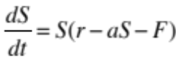

The maximum sustainable yield, defined as the stock that yields the greatest flow, is S_{MSY} = r/2a, and the harvest rate leading to this is F_{MSY} = r/2. Harvest rates are thus normalized as 2F/r to obtain F/F_{MSY}, which takes the value 1 when a stock is harvested at F_{MSY}.

A simple utility function expresses the flow of utility u (such as money per year) to a community over time:

Equation 3

u = Vφ ln(FS) - IFS

V is the maximum positive marginal income from fishing and I is a constant marginal cost of harvesting a unit of stock. φ is a constant that scales the income (ln) function and allows V and I to share the same unit. The units for the variables in Equation 3 are:

Equation 4

[$/yr] = [$/kg][kg/yr][1] - [$/kg][1/yr][kg]

where $ is in millions US. The quantity ln(FS) is dimensionless because logarithms are transcendental functions⁴⁸. These unit identifications will facilitate how we can insert empirical observations into Equation 3 later on.

Assuming that the resource is excludable within a community, the stock will converge to equilibrium S* (from solving Equation 2) according to the community’s strategy – the harvest rate – before harvest rate is compelled to change by small steps. In other words, there is a time -scale separation between fast ecological dynamics and slow strategy dynamics. The change in strategy over time, dF/dt, is proportional to the change in utility (Equation 3) as a function of change in strategy, ∂u/∂F, according to standard evolutionary game models based on the fitness (or utility) hill climbing analogy^{49–52}.

Equation 5

$$\frac{∂u}{∂F}=\frac{∂}{∂F}\left(Vϕln\left(FS^{*}\right)-IFS^{*}\right)=\frac{r-2F}{a}\left(\frac{Vϕa}{F\left(r-F\right)}-I\right)$$

The equilibria of Equation 5 are either evolutionarily stable or unstable harvesting strategies:
Equation 6

$$F^{*}=\frac{r}{2}, \frac{1}{2}\left(r±\sqrt{r^{2}-4aϕV/I}\right)$$

The first solution is stable for 0 ≤ I/V ≤ 4aφ/r² since ∂²u/∂F²<0; for greater I, a pitchfork bifurcation occurs, where the second and third solutions are stable, while the first solution is unstable (Supplementary). The bifurcation point is thus 4aφ/r², which is equivalent to φ/MSY. As MSY of the stock increases, the bifurcation point along the I/V axis shifts to the left (to a smaller cost/benefit ratio). That is, the region of I/V where harvesting at MSY rate is stable shrinks as MSY increases. As I/V approaches infinity, the stable solutions asymptotically approach r and 0. A more enlightening formulation of the solutions in Equation 6 are the logarithms of relative harvest rates log₂(F*/F_{MSY}):

Equation 7
$$\hat{F^{*}}=0,\log_{2}\left(1±\sqrt{1-\frac{ϕ}{MSY I/V}}\right)$$

Using standard economic optimization methods on the managed harvest of renewable resources^{34,53}, we obtain the same equilibria as in Equation 6 and Equation 7 (see Supplementary Information).

Analysis

To fit the model solutions in Equation 7 to data, we estimate the fishery-specific cost-benefit ratio I/V from the empirical community-wide cost-benefit ratio γ. In addition, since MSY is arbitrarily defined with a unit of kg, a multiplicative factor is inserted such that MSY=ωMSY[kg]. Suppose that each community’s total fish landing is C_{T}=ξωMSY[kg], or ξ times the observed fishery’s potential, and that each community follows the utility function in Equation 3. Then, γ is the ratio of total community cost over benefit in terms of MSY, which contains the I/V ratio as derived below.

Equation 8

$$γ=\frac{IC_{T}}{Vϕln(C_{T})}=\frac{IξωMSY[kg]}{Vϕln(ξωMSY[kg])}$$

$$\frac{ϕ}{MSY I/V}=\frac{ξ}{ln\left(\hat{ω}MSY[kg]\right)γ}$$

where $\hat{ω}$ = ξω, a multiplicative factor of MSY inside the ln function. The right hand side of the final expression in Equation 8 directly plugs into Equation 7, yielding the model solutions that can be fitted to data:

Equation 9

$$\hat{F^{*}}=0,\log_{2}\left(1±\sqrt{1-\frac{ξ}{ln⁡(\hat{ω}MSY\left[kg\right])γ}}\right)$$

To fit the model to data, we can estimate ξ and $\hat{ω}$ as constant parameters using an iterative search procedure to minimize the non-linear least squares. Since the model (Equation 9) predicts two possible stable strategies for γ >ξ/(ln(MSY)), the expected solution is chosen according to each fishery’s initial condition. If a fishery’s first reported harvest rate F_{init} is below F_{MSY} (which is the unstable solution in the bistable region), then the model predicts that the fishery will subsequently converge to the smaller $\hat{F^{*}}$. Conversely, if the initial harvest rate is above F_{MSY}, then the fishery is expected to converge to the larger $\hat{F^{*}}$. The initial condition is thus binary (either above or below F_{MSY}). For the model analysis, the dependent variable that we wish to predict is the average F*/F_{MSY} of each fishery over all available years between 1961 and 2009, excluding the first available year.

While$\hat{ω}$ modifies the unit of MSY, it does not strongly affect the value of ξ/ln($\hat{ω}MSY[kg]$), which is the quantity that determines the model predictions on harvest rates, when ξ is fitted at the chosen unit. This is shown as the sensitivity of the model R² to the chosen unit of MSY (Figure 4). For all tested units where ln(MSY) is positive for all fisheries, the R² is close to the maximum. We set the unit to kg ($\hat{ω}$=1), which is very close to the best fitting unit of 0.581 kg. In the main results, the model essentially contains a single parameter ξ, with MSY being understood to have the unit of kg.

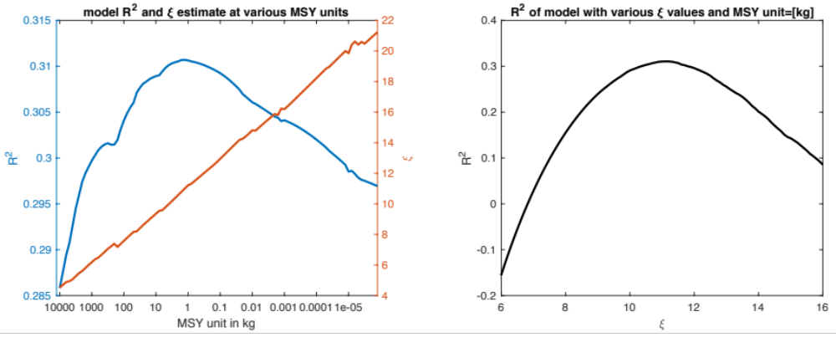
Figure 4. a. Sensitivity of model, as evaluated by R², to MSY unit. b. Model R² as a function of the parameter ξ with MSY in kg.

The significance of the model fit and parameter estimate are evaluated using a permutation test^{37–39}. We permute, without replacement, the mean harvest rate F, which is what the model attempts to explain. To keep the time series of each fishery intact, the initial harvest rate remains paired with the mean harvest rate (which excludes the first year) through the permutation. The cost/benefit ratio γ and MSY remain as original pairs to retain the fishery data structure. The model is fitted to the permuted data, which generates an R² and a ξ estimate. By performing the permutation 100000 times, we generate null distributions of R² and ξ for the model, with the null hypothesis being that there is no relationship between harvest rate and the predictor variables (γ and MSY) in our model. The one-sided p-value of the original R², fitted to the original data, is the fraction of the permuted fits whose R² are larger. This is the significance of the model. The one-sided p-value of the model fit to permuted harvest rate is the fraction of R² greater than 0 in the permuted set, and indicates the model’s fit to the pure harvest rate distribution without regard to γ and MSY. The two-sided p-value of the original ξ estimate is 2x the smaller of the fractions of permuted ξ estimates that are either larger or smaller. The result is shown in Figure 5. The insignificance of the estimate indicates that ξ fits to the pure harvest rate distribution, and that any additional variations explained by the full model comes from part of the model that is parameter-independent.

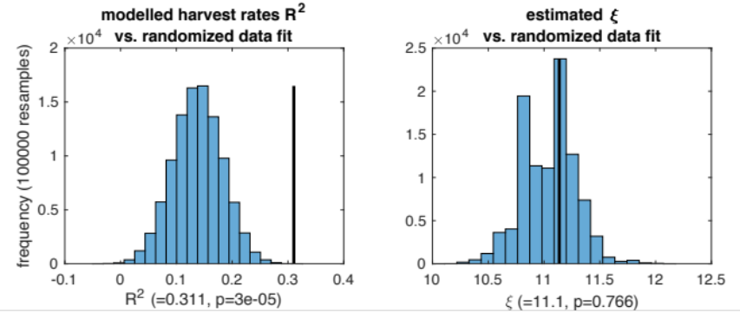
Figure 5. Estimated parameter ξ (black vertical line) compared to null distributions generated from permutation tests.

References

1. UN. Sustainable Development Goals. (2015). at <http://www.un.org/sustainabledevelopment/>
2. Levin, S. et al. Social-ecological systems as complex adaptive systems: modeling and policy implications. Environ. Dev. Econ. 18, 111–132 (2013).
3. Horan, R. D., Fenichel, E. P., Drury, K. L. S. & Lodge, D. M. Managing ecological thresholds in coupled environmental-human systems. Proc. Natl. Acad. Sci. U. S. A. 108, 7333–7338 (2011).
4. Fenichel, E. P. & Horan, R. D. Tinbergen and tipping points: Could some thresholds be policy-induced? J. Econ. Behav. Organ. (2016). doi:10.1016/j.jebo.2016.06.014
5. Jacob, F. Evolution and tinkering. Science 196, 1161–1166 (1977).
6. Gould, S. J. The evolution of life on the earth. Sci. Am. 271, 84–91 (1994).
7. Waddington, C. H. Canalization of development and the inheritance of acquired characters. Nature 150, 563–565 (1942).
8. Ferrell, J. E. Self-perpetuating states in signal transduction: Positive feedback, double-negative feedback and bistability. Curr. Opin. Cell Biol. 14, 140–148 (2002).
9. Wilhelm, T. The smallest chemical reaction system with bistability. BMC Syst. Biol. 3, 90 (2009).
10. Ives, A. R., Einarsson, A., Jansen, V. a a & Gardarsson, A. High-amplitude fluctuations and alternative dynamical states of midges in Lake Myvatn. Nature 452, 84–87 (2008).
11. Beisner, B. E., Haydon, D. T. & Cuddington, K. Alternative stable states in ecology. Front. Ecol. Environ. 1, 376–382 (2003).
12. Hartman, A. L. et al. Human gut microbiome adopts an alternative state following small bowel transplantation. Proc. Natl. Acad. Sci. 106, 17187–17192 (2009).
13. Staver, A. C., Archibald, S. & Levin, S. The global extent and determinants of savanna and forest as alternative biome states. Science 334, 230–232 (2011).
14. Scheffer, M., Hirota, M., Holmgren, M., Van Nes, E. H. & Chapin, F. S. Thresholds for boreal biome transitions. Proc. Natl. Acad. Sci. U. S. A. 109, 21384–9 (2012).
15. Ling, S. D. et al. Global regime shift dynamics of catastrophic sea urchin overgrazing. Philos. Trans. R. Soc. B Biol. Sci. 370, 20130269 (2015).
16. David, P. a. in Evolution and Path Dependence in Economic Ideas: Past and Present (eds. Garrouste, P. & Ioannides, S.) 15–36 (Edward Elgar, 2000). doi:DOI:
17. North, D. C. Institutions, institutional change and economic performance. (Cambridge University Press, 1990).
18. Pierson, P. Increasing returns, path dependence, and the study of politics. Am. Polit. Sci. Rev. 94, 251–267 (2000).
19. Ricard, D., Minto, C., Jensen, O. P. & Baum, J. K. Examining the knowledge base and status of commercially exploited marine species with the RAM Legacy Stock Assessment Database. Fish Fish. 13, 380–398 (2012).
20. Sumaila, U. R. et al. Benefits of rebuilding global marine fisheries outweigh costs. PLoS One 7, (2012).
21. Deroba, J. J. & Bence, J. R. A review of harvest policies: Understanding relative performance of control rules. Fish. Res. 94, 210–223 (2008).
22. FAO. Code of Conduct for Responsible Fisheries. Food Agric. Organ. United Nations (1995). doi:ISBN 92-5-103834-5
23. Botsford, L. W., Castilla, J. C. & Peterson, C. H. The Management of Fisheries and Marine Ecosystems. Science 277, 509–515 (1997).
24. FAO. The State of World Fisheries and Aquaculture. (2016).
25. Steele, J. H. Regime shifts in the ocean: Reconciling observations and theory. Prog. Oceanogr. 60, 135–141 (2004).
26. Hicks, C. C., Crowder, L. B., Graham, N. A. J., Kittinger, J. N. & Le Cornu, E. Social drivers forewarn of marine regime shifts. Front. Ecol. Environ. 14, 252–260 (2016).
27. Lade, S. J. et al. An empirical model of the Baltic Sea reveals the importance of social dynamics for ecological regime shifts. Proc. Natl. Acad. Sci. U. S. A. 112, 11120–5 (2015).
28. Collie, J. S., Richardson, K. & Steele, J. H. Regime shifts: Can ecological theory illuminate the mechanisms? Prog. Oceanogr. 60, 281–302 (2004).
29. Roughgarden, J. & Smith, F. Why fisheries collapse and what to do about it. Proc. Natl. Acad. Sci. U. S. A. 93, 5078–5083 (1996).
30. Ostrom, E. Governing the Commons: The Evolution of Institutions for Collective Action. (Cambridge University Press, 1990).
31. Clark, C. W. The economics of overexploitation. Science 181, 630–634 (1973).
32. Pauly, D. Anecdotes and the shifting baseline syndrome of fisheries. Trends Ecol. Evol. 10, 430 (1995).
33. Heal, G. M. Economic Theory and Sustainability. (Columbia University Press, 1998).
34. Smith, V. L. Economics of production from natural resources. Am. Econ. Rev. 58, 409–431 (1968).
35. Clark, C. & Munro, G. The economics of ﬁshing and modern capital theory: a simpliﬁed approach. J. Environ. Econ. Manage. 2, 92–106 (1975).
36. Dasgupta, P., Mitra, T. & Sorger, G. Harvesting the Commons. 1–36 (2016).
37. Neyman, J. S. On the application of probability theory to agricultural experiments: principles. Rocz. Nauk Rol. 10, 1–51 (1923).
38. Fisher, R. Statistical Methods and Scientific Induction. J. R. Stat. Soc. Ser. B 17, 69–78 (1955).
39. Anderson, M. J. Permutation tests for univariate or multivariate analysis of variance and regression. Can. J. Fish. Aquat. Sci. 58, 626–639 (2001).
40. Lubchenco, J., Cerny-chipman, E. B., Reimer, J. N. & Levin, S. A. The right incentives enable ocean sustainability successes and provide hope for the future. (2016). doi:10.1073/pnas.1604982113
41. Dasgupta, P. Discounting climate change. J. Risk Uncertain. 37, 141–169 (2008).
42. Fenichel, E. P. et al. Wealth reallocation and sustainability under climate change. Nat. Clim. Chang. 6, 237–244 (2016).
43. Turchin, P. Complex Population Dynamics: A Theoretical/Empirical Synthesis. (Princeton University Press, 2003).
44. Ludwig, D., Walker, B. & Holling, C. S. Sustainability, stability, and resilience. Conserv. Ecol. 1, (1997).
45. Costello, C. et al. Global fishery futures under contrasting management regimes. Proc. Natl. Acad. Sci. U. S. A. in review (2016). doi:10.1073/pnas.0709640104
46. Halpern, B. S. et al. An index to assess the health and benefits of the global ocean. Nature 488, 615–620 (2012).
47. Ghosh, A. The Great Derangement. (The University of Chicago Press, 2016).
48. Matta, C. F., Massa, L., Gubskaya, A. V. & Knoll, E. Can one take the logarithm or the sine of a dimensioned quantity or a unit? Dimensional analysis involving transcendental functions. J. Chem. Educ. 88, 67–70 (2011).
49. Wright, S. The roles of mutation, inbreeding, crossbreading and selection in evolution. Proc. Sixth Int. Congr. Genet. 1, 356–366 (1932).
50. Metz, J. A. J., Geritz, S. A. H., Meszéna, G., Jacobs, F. J. A. J. A. & van Heerwaarden, J. S. S. in Stochastic and Spatial Structures of Dynamical Systems (eds. van Strien, S. J. & Verduyn Lunel, S. M.) 45, 183–231 (North Holland, 1996).
51. Dieckmann, U. & Law, R. The dynamical theory of coevolution: a derivation from stochastic ecological processes. J. Math. Biol. 34, 579–612 (1996).
52. Rice, S. H. Evolutionary Theory. (Sinauer, 2004).
53. Dasgupta, P., Mitra, T. & Sorger, G. Harvesting the Commons. Vienna Econ. Pap. Univ. Vienna, Dep. Econ. (2016). at <http://econpapers.repec.org/RePEc:vie:viennp:1608>

